**Task 2**

Initial IP address: 192.168.1.0/24

**Subnet C 🡪 No. of hosts = 60 || 2^n-2 = 60 | n = 6**

Next Hop = 64

New subnet (binary) =1111 1111.1111 1111.1111 1111.1100 0000

New subnet (decimal) =255.255.255.192 or / 26

Network IP = 192.168.1.0

Host Range =192.168.1.1 - 192.168.1.62

Broadcast IP = 192.168.1.63

**Subnet B 🡪 No. of hosts = 30 || 2^n-2 = 30 | n = 5**

Next Hop = 32

New subnet (binary) =1111 1111.1111 1111.1111 1111.1110 0000

New subnet (decimal) =255.255.255.224 or / 27

Network IP = 192.168.1.64

Host Range = 192.168.1.65 - 192.168.1.94

Broadcast IP = 192.168.1.95

**Subnet A 🡪 No. of hosts = 14 || 2^n-2 = 14 | n = 4**

Next Hop = 16

New subnet (binary) **=** 1111 1111.1111 1111.1111 1111.1111 0000

New subnet (decimal) =255.255.255. 240 or / 28

Network IP = 192.168.1.96

Host Range = 192.168.1.97 - 192.168.1.110

Broadcast IP = 192.168.1.111

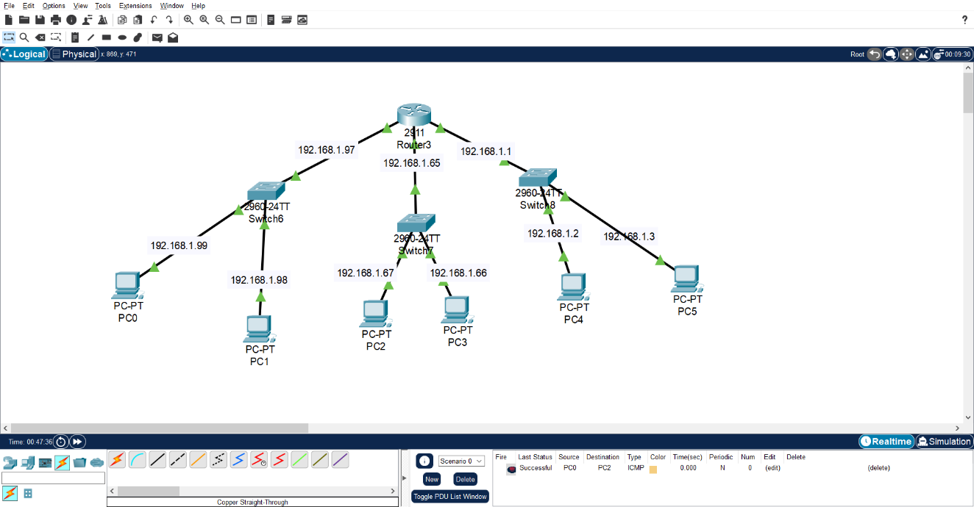

Interfaces Configurations

G0/0:

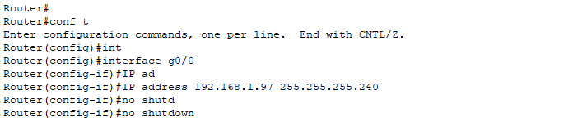G0/1:

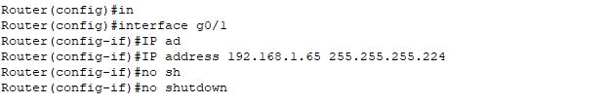G0/2:

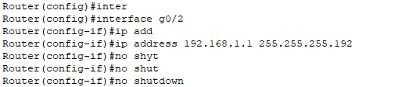

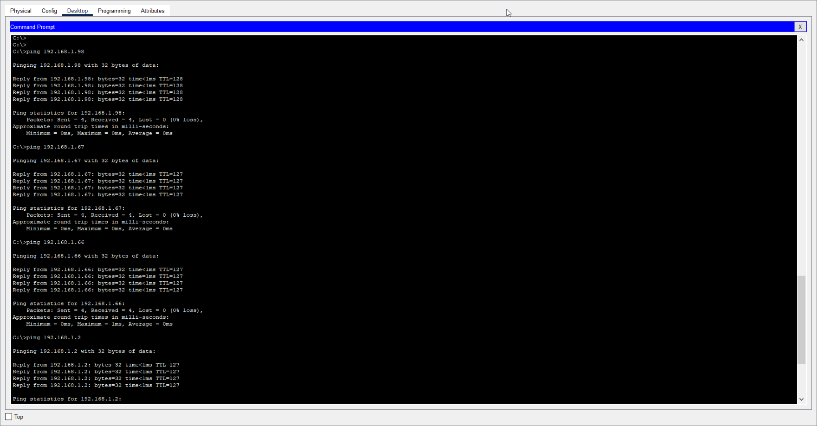**Ping from PC0 to all other PCs**

